**PROJECT NAME – FOODBOX**

**Developer Name – Malini Murthy**

**Email id – krmalini77@gmail.com**

**Contact No – 414-629-6041**

Front End : [malinimurthy123/foodbox (github.com)](https://github.com/malinimurthy123/foodbox)

Back End : [malinimurthy123/foodbox at FoodBoxBackend (github.com)](https://github.com/malinimurthy123/foodbox/tree/FoodBoxBackend)

Automation : [malinimurthy123/foodbox at FoodBoxSeleniumAutomation (github.com)](https://github.com/malinimurthy123/foodbox/tree/FoodBoxSeleniumAutomation)

**Project Description: An ecommerce Application design for the food delivery purpose using this application we can buy a food and do payment online and it include admin page and user page user can buy food and give feedback and there is admin dashboard who can handle this application. Example - He can add, delete, update food and maintain the Customer list**

**Environment:**

**Backend – Java 17, Spring Boot 3.0.6, Spring Data JPA 2.7.5**

**Database – MySQL**

**Frontend – Typescript, JavaScript, Angular 17 , HTML , CSS , JQUERY , Angular Material**

**DevOps Tools – GitHub, Jenkins, Docker(for learning purpose)**

my sql : malini123

malini/ malini123

Win service name : MySQL80

root / malini123

schema : foodbox

Jenkins Screens:

foodBox Jenkins pipeline integration with Github that has the code :

<http://localhost:8080/>

Malini / Malini

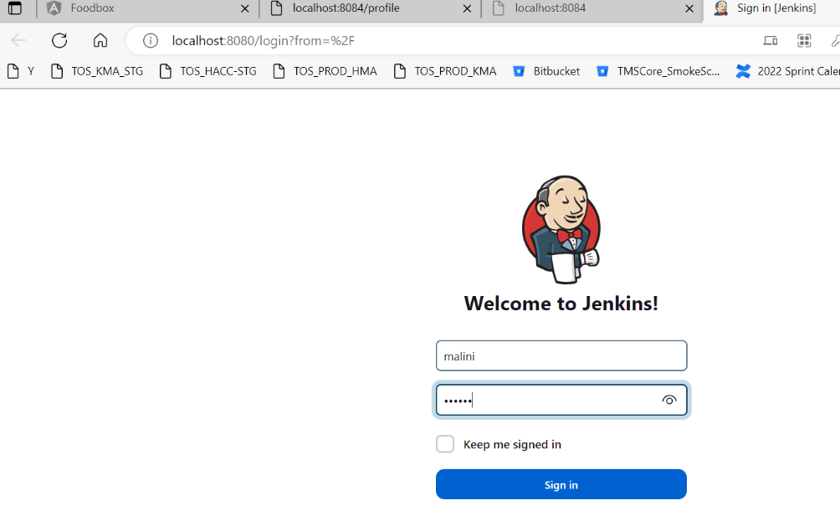

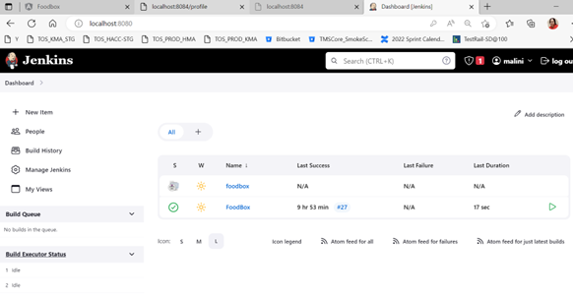

Scheduled Builds running:

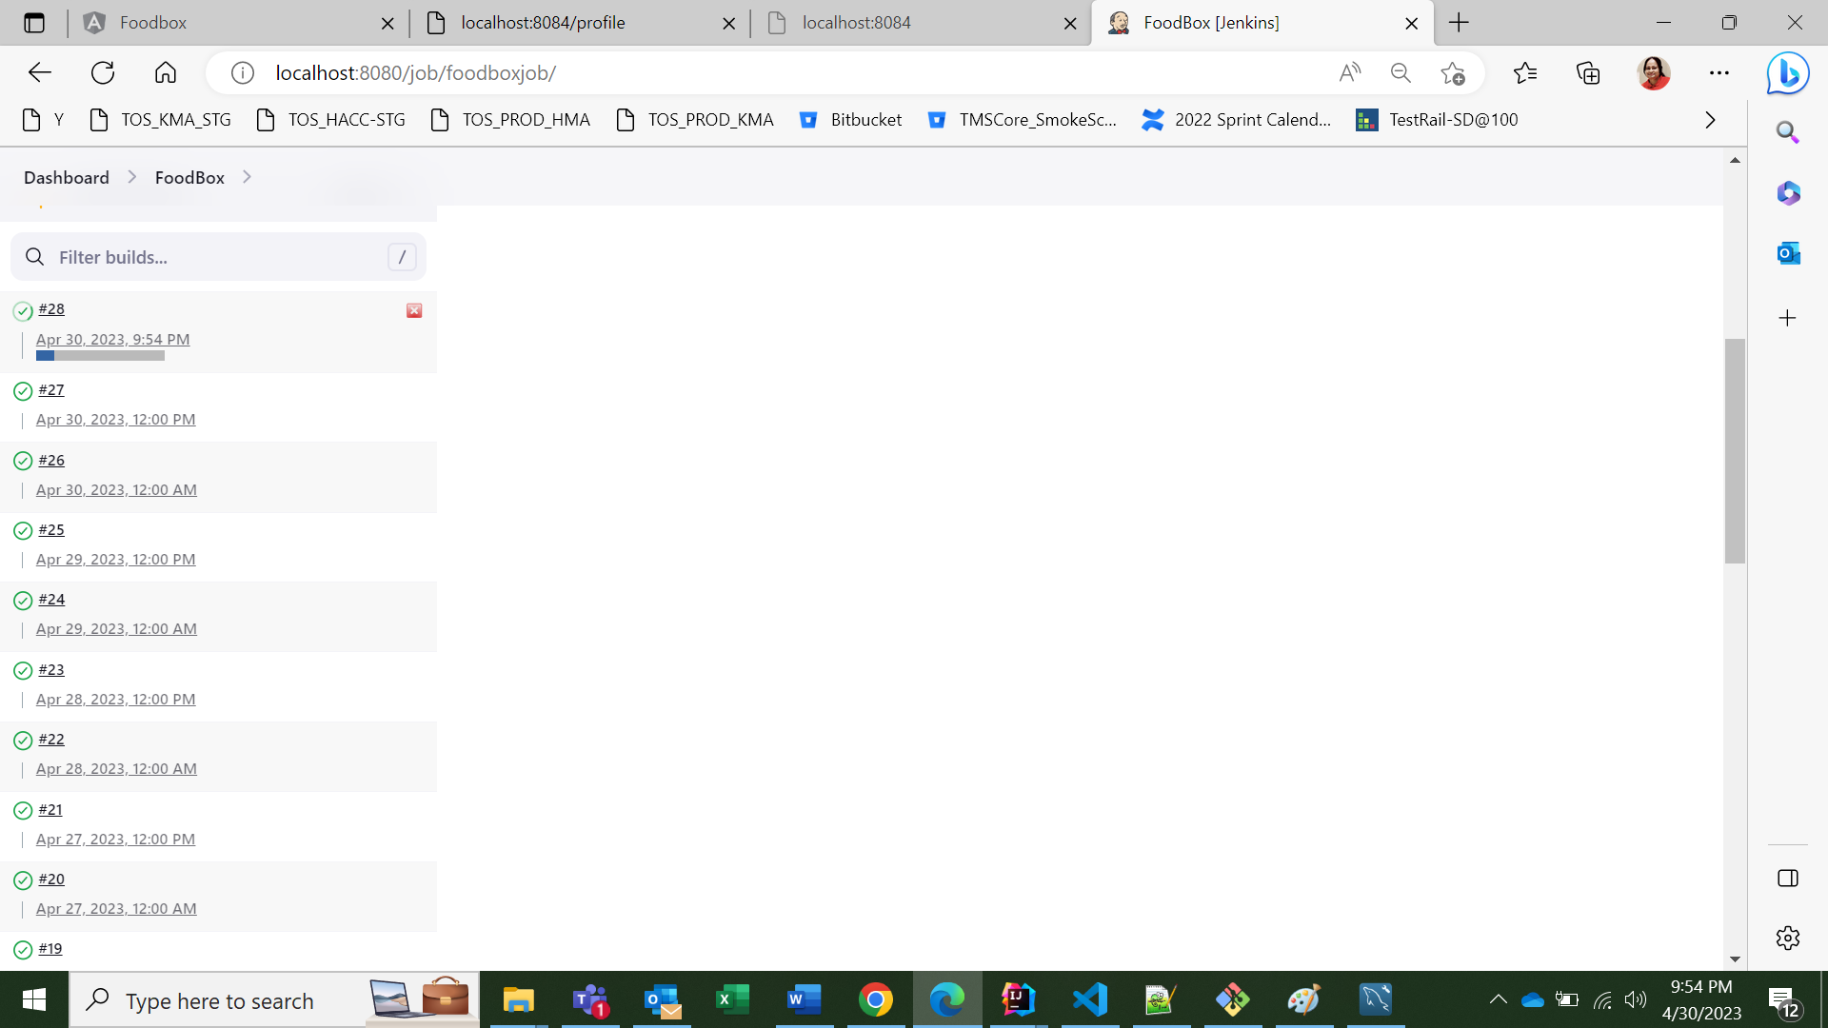

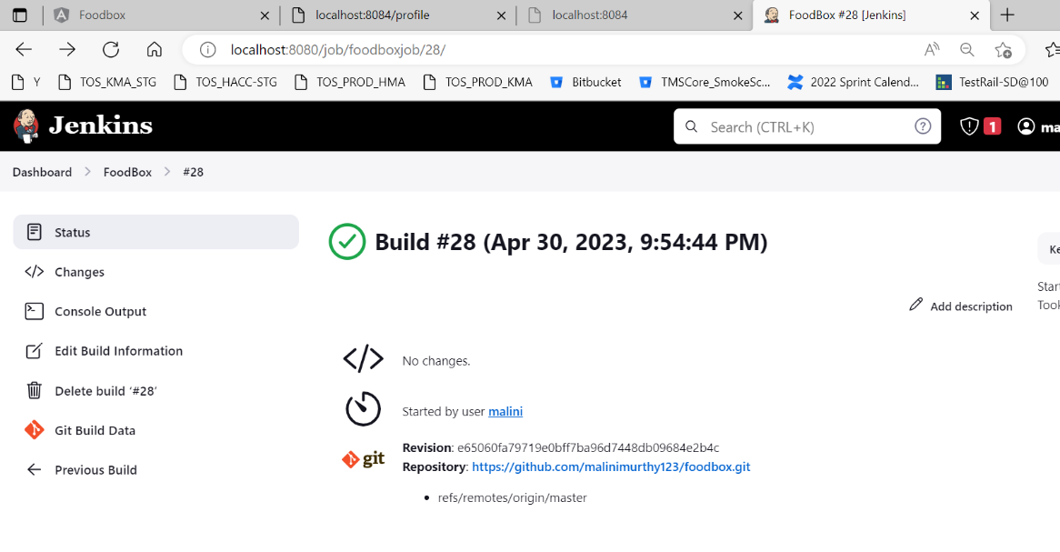

Scheduled Job runs are successful:

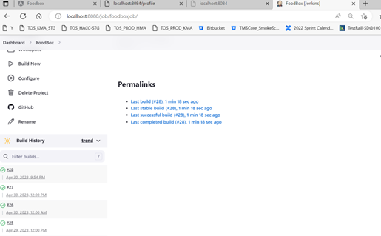

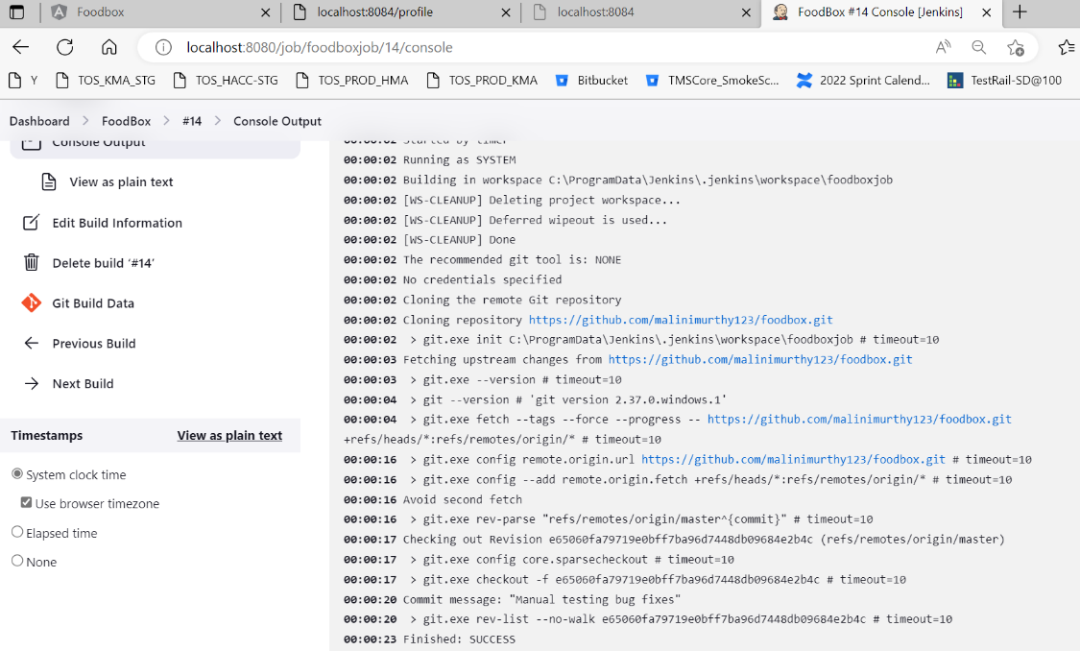

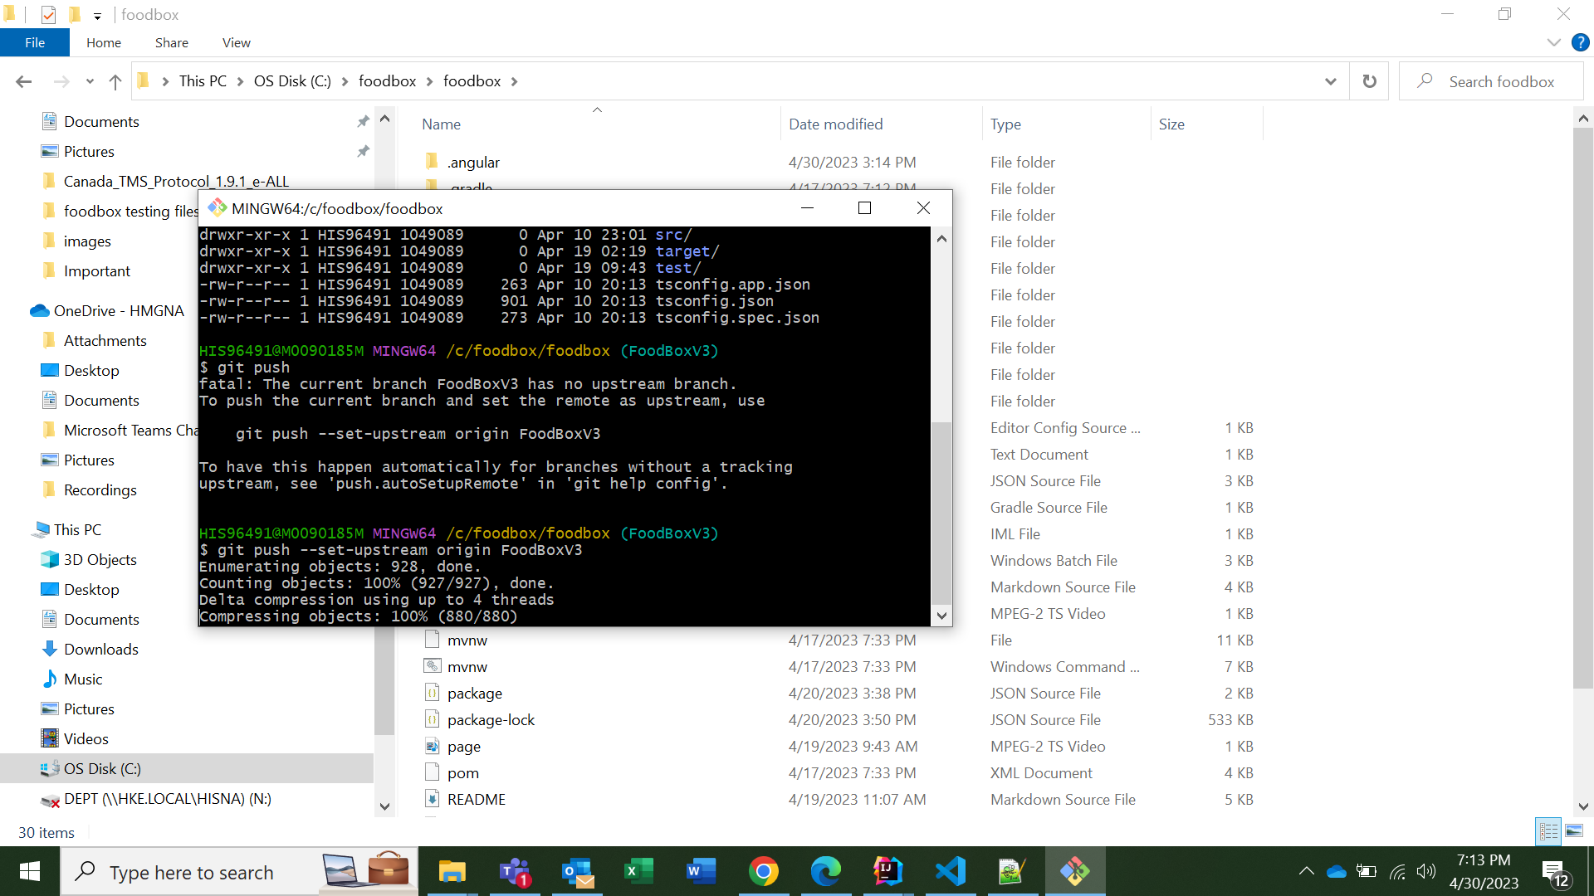

Docker Image of FoodBox Project:

docker build -t image_name:tag_number ./

FROM node:18-alpine

ENV NODE_ENV=production

WORKDIR /app

COPY ["package.json", "package-lock.json*", "./"]

RUN npm install --production

COPY . .

CMD ["node", "server.js"]

EXPOSE 4200

# COPY --from=node /app/dist/food-box-front-end  /usr/share/nginx/html

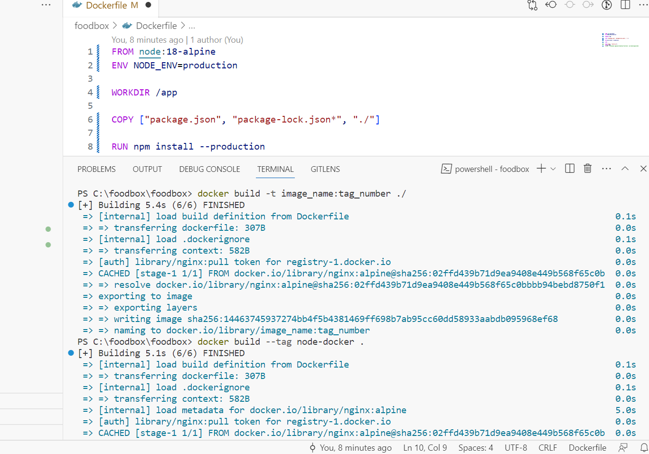

docker build --tag node-docker .

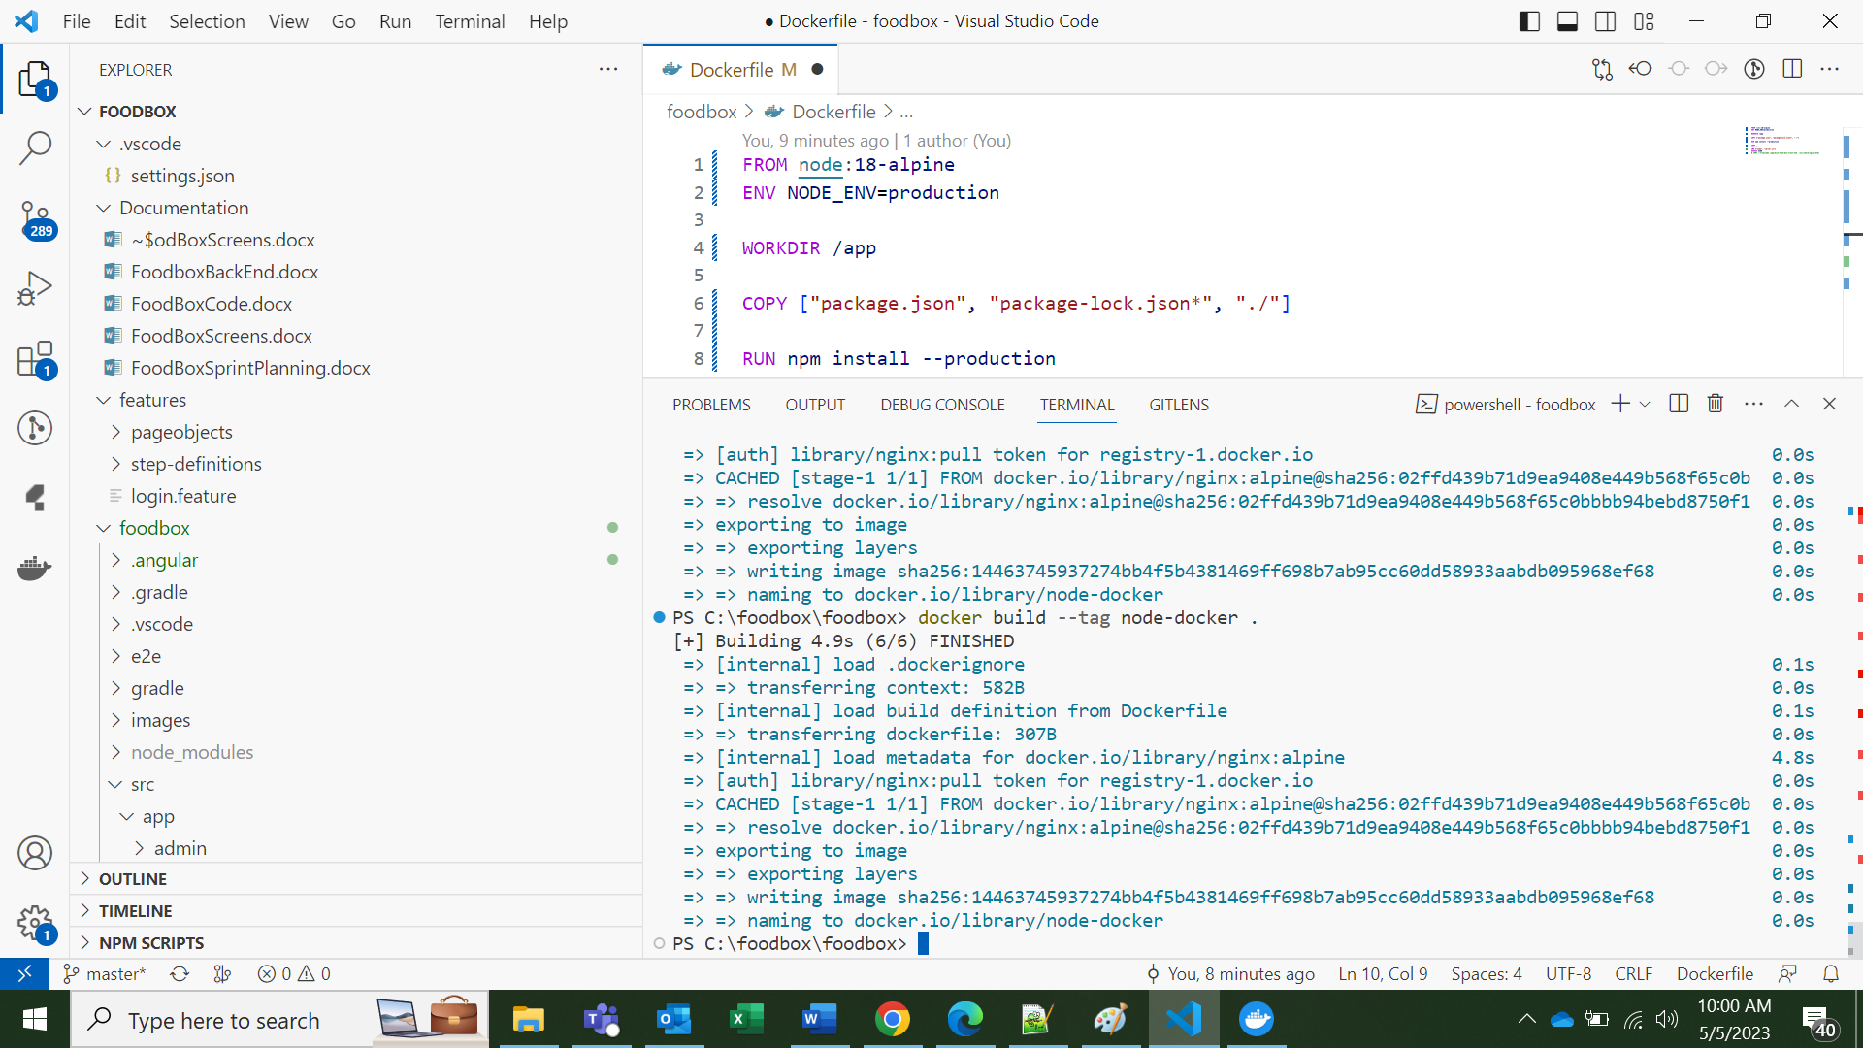

To create a new tag for the image we built above, run the following command.

View the Image in the Docker Hub:

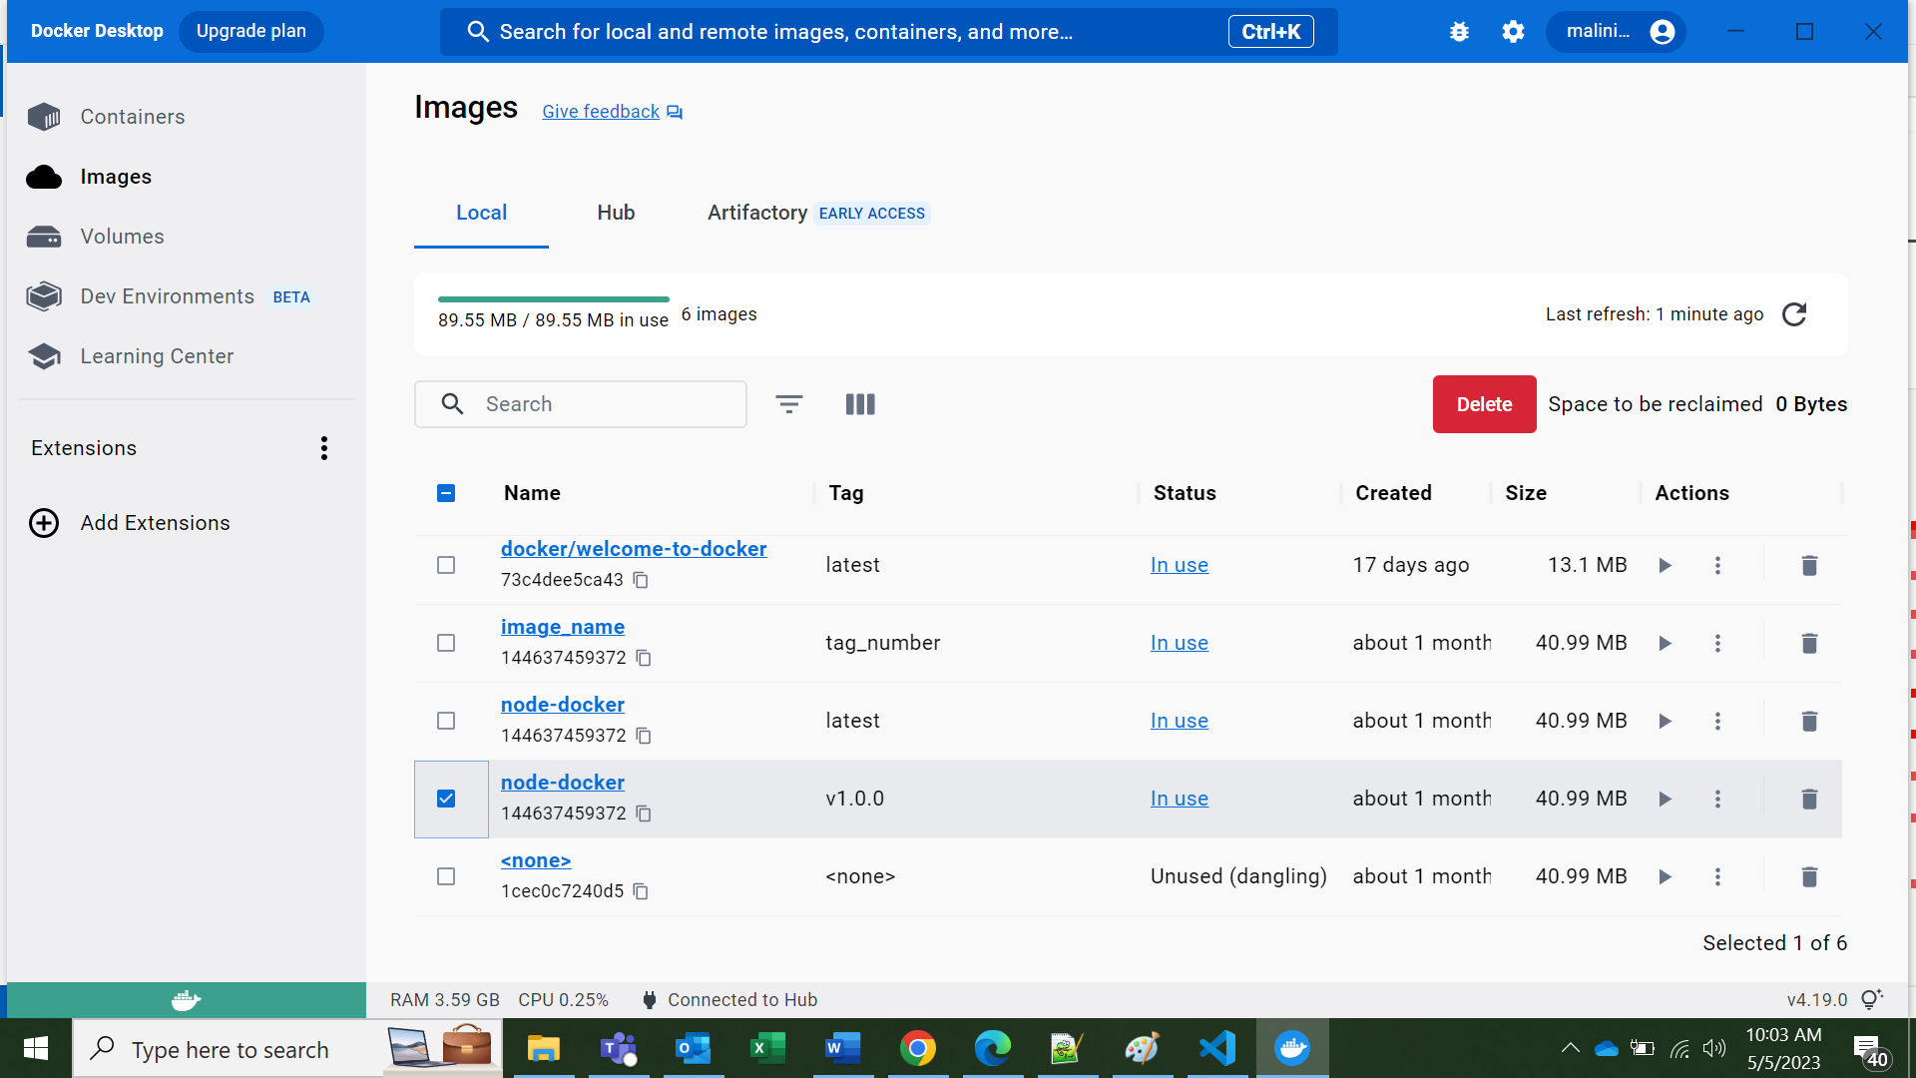

curl --request POST \

--url http://localhost:4200/test \

--header 'content-type: application/json' \

--data '{"msg": "testing"}'

docker run -d -p 4200:4200 node-docker

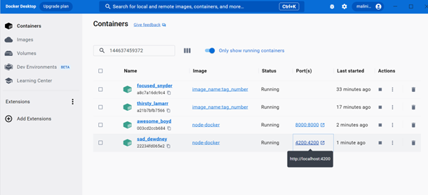

Application is running:

## Home Page of my Application…

## user can login to be able to view items and add to cart and buy the food if he trying to add food without login there is error showing that you can login first then you can able to add this food to cart

**frontend running on port 4200**

**When user can open application then he can see the register and login button and once he register and login then this login and register button will disappear and In place of that we can see cart icon and in Navbar also we can see my Account list in y account user can see he’s profile and order related thing**

**Even user can search food by using food name, type(veg), category(Indian, Chinese, Briyani etc)**

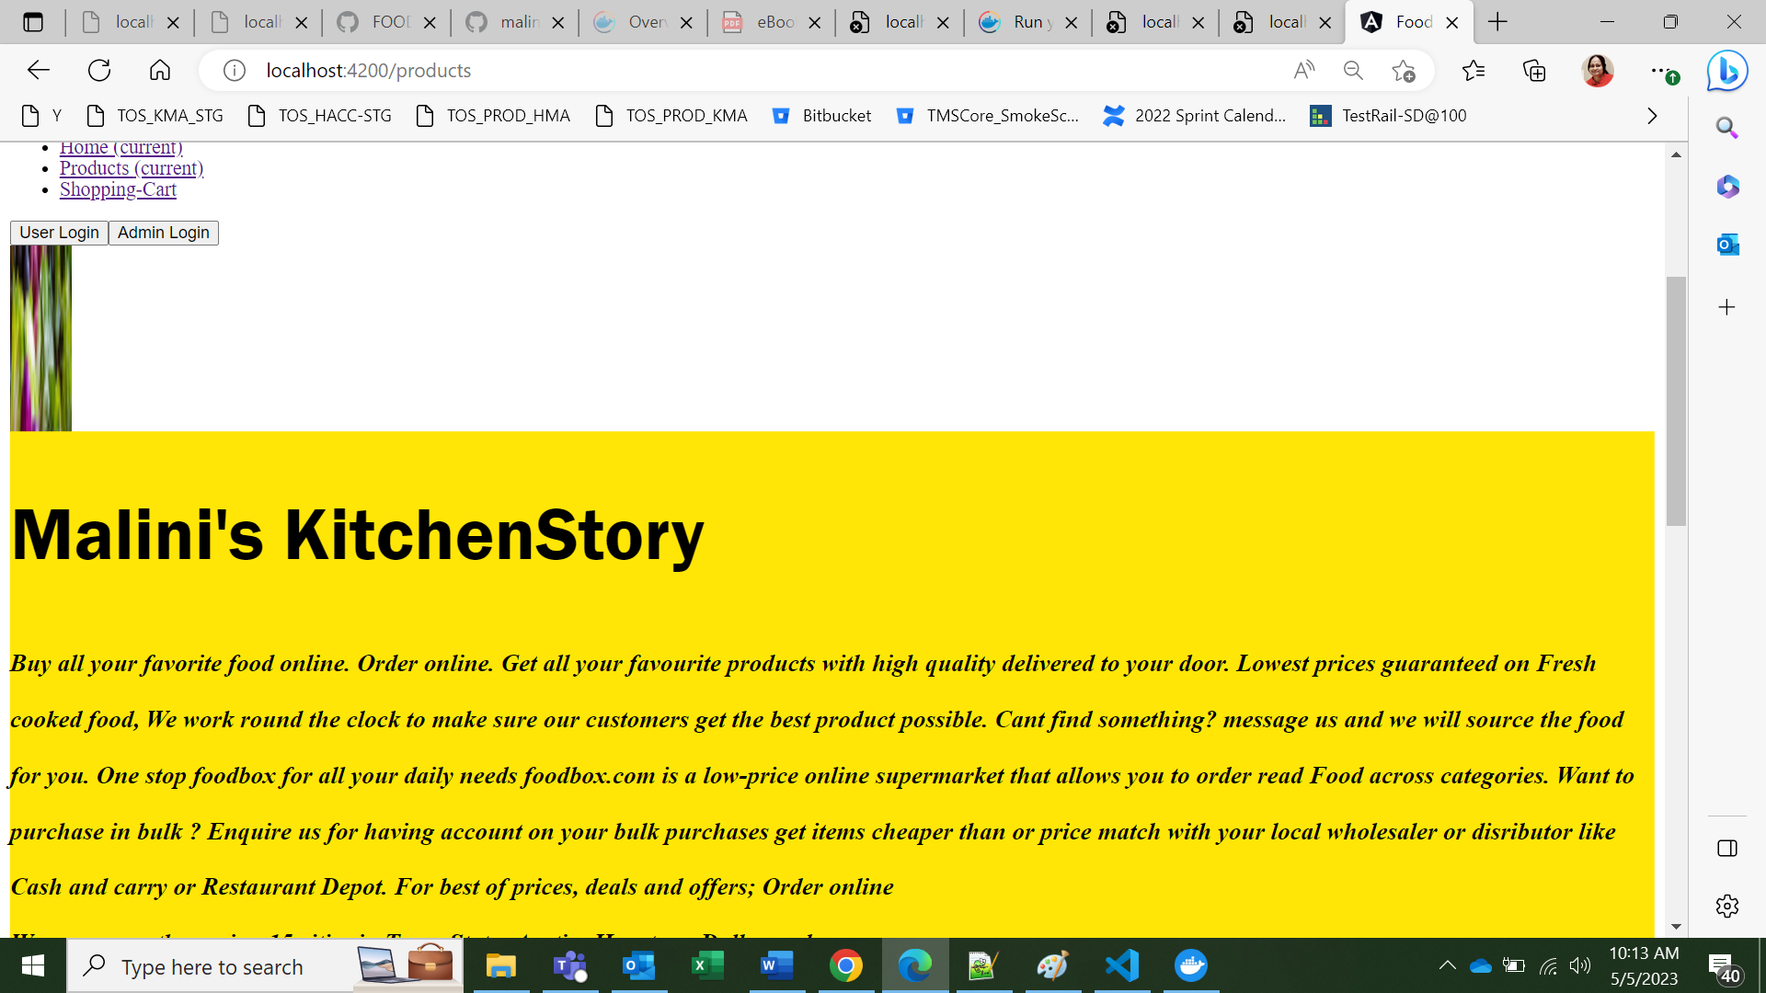

* 1. **Project Description:**

DESCRIPTION

Create a dynamic and responsive online food delivery web application for ordering food items of different cuisines from a restaurant.

**Background of the problem statement:**

Foodbox is a restaurant chain that delivers food items of different cuisines at affordable prices. It was established in 2014 in Bengaluru, India. It had been serving fine all these years, however, the business analysts noticed a decline in sales since 2016. They found out that the online ordering of food items with companies, such as Swiggy and Foodpanda were gaining more profit by eliminating middlemen from the equation. As a result, the team decided to hire a Full Stack developer to develop an online food delivery web application with a rich and user-friendly interface.  
You are hired as the Full Stack Java developer and are asked to develop the web application. The management team has provided you with the requirements and their business model so that you can easily arrange different components of the application.

**Features of the application:**

1. Registration
2. Login
3. Payment gateway
4. Searching
5. Filtering
6. Sorting
7. Dynamic data
8. **Architecture diagram / flow chart**

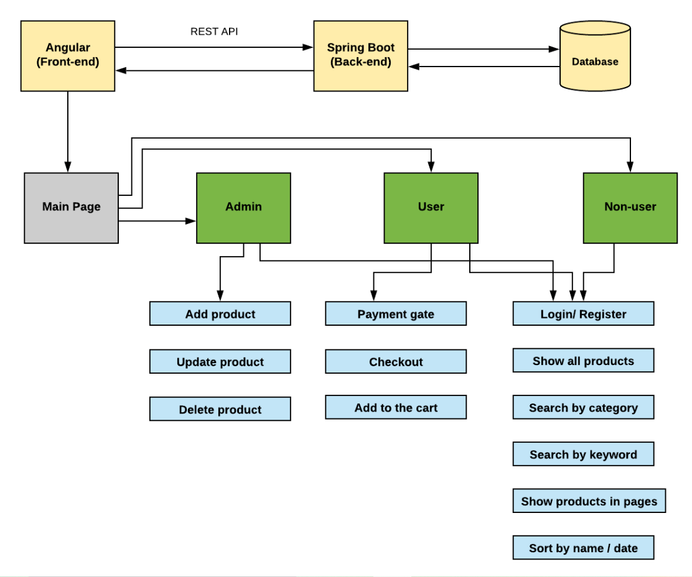

**Front End : Screens**

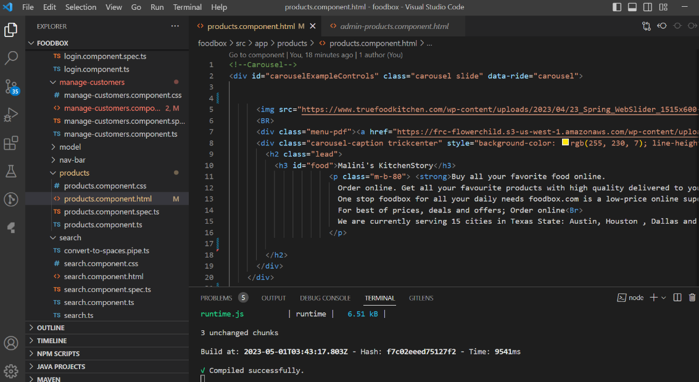

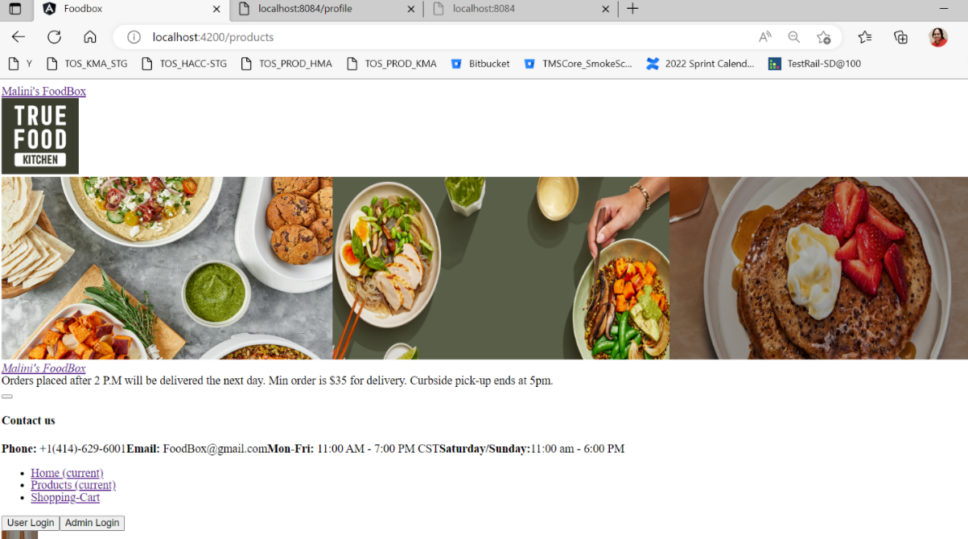

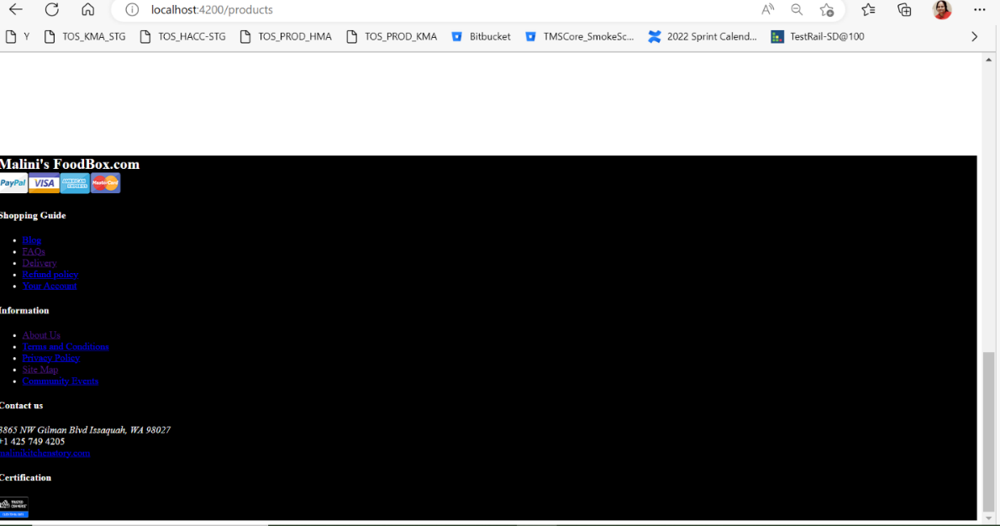

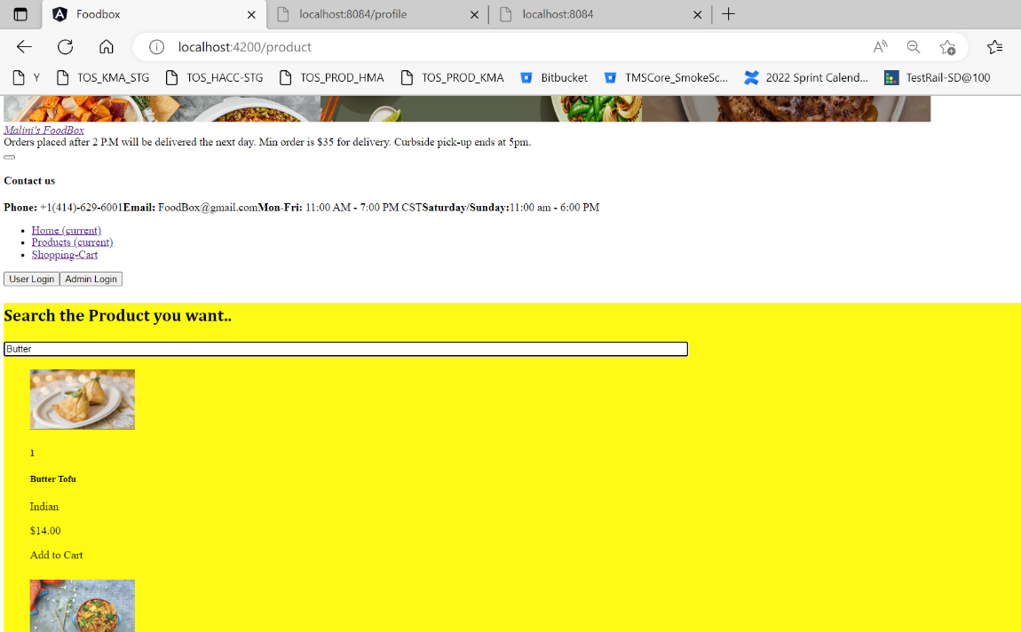

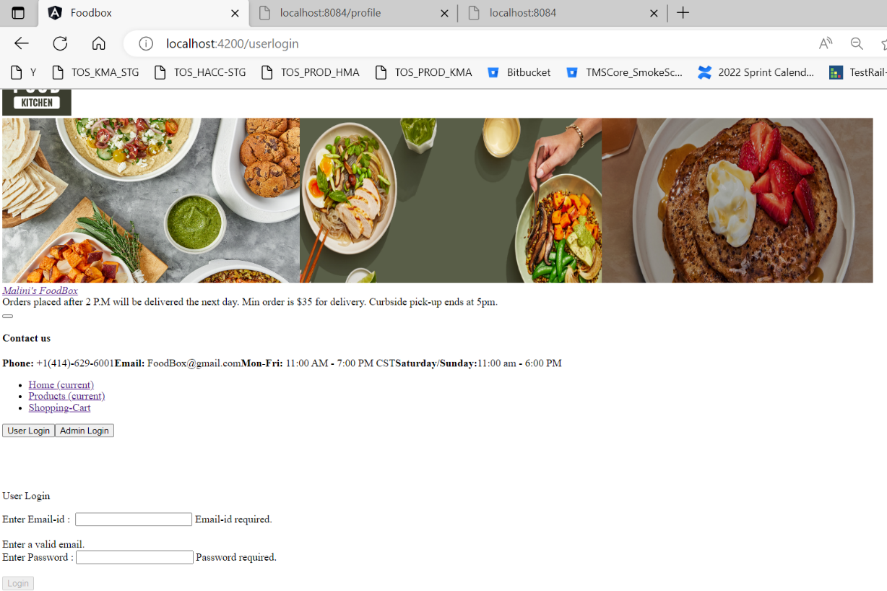

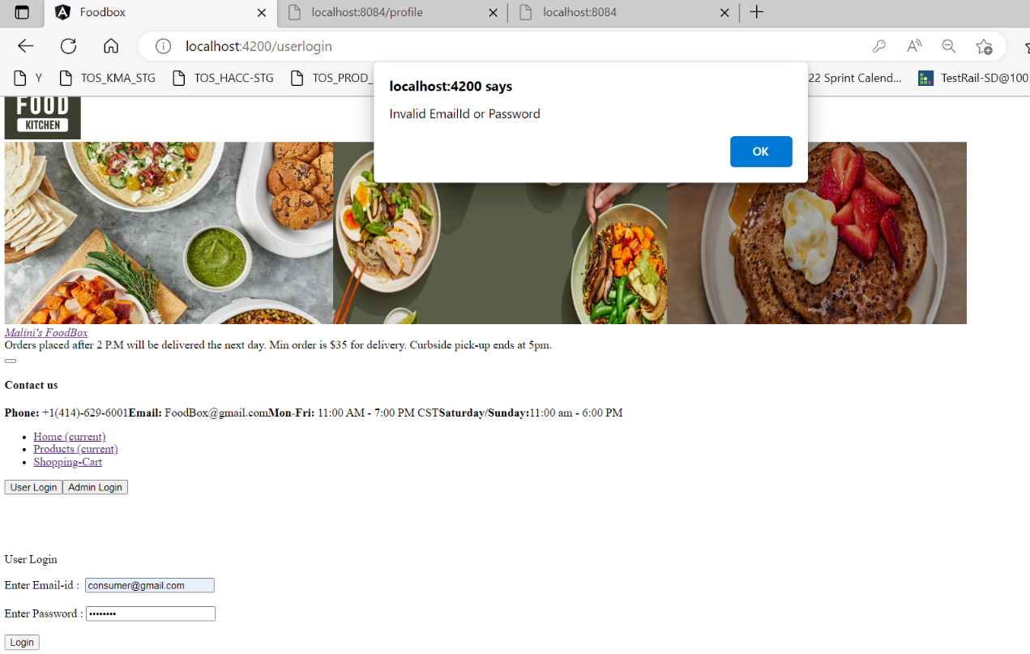

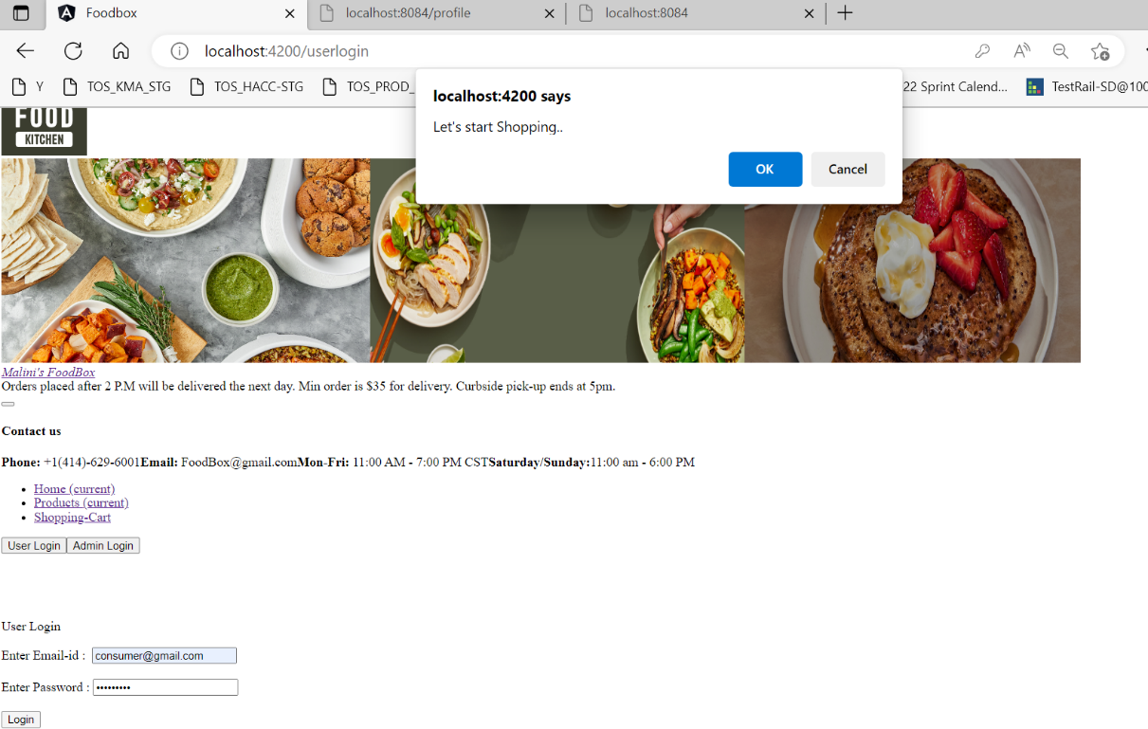

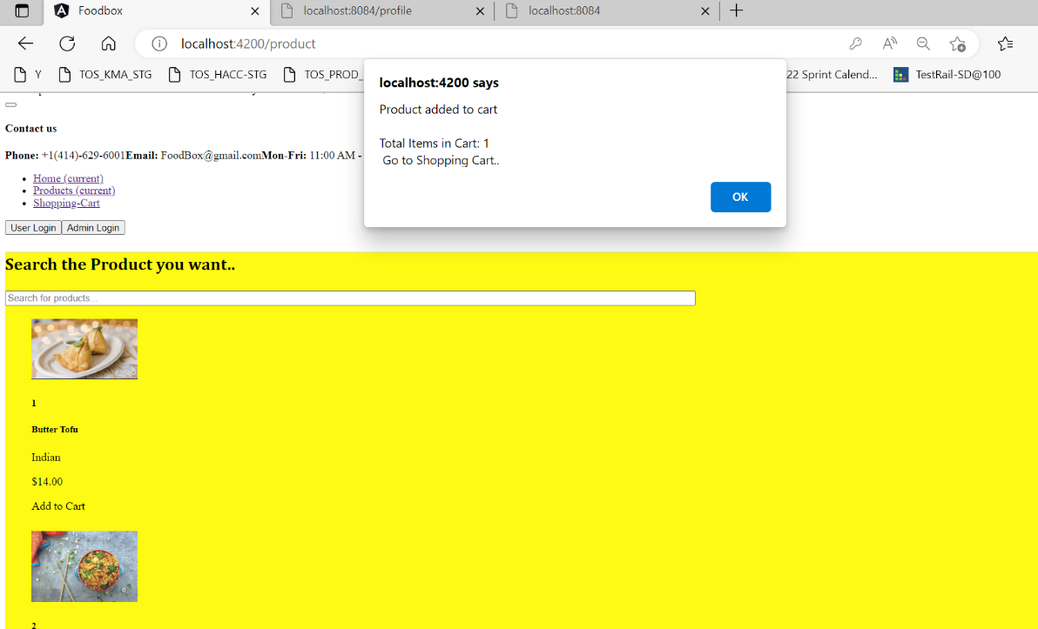

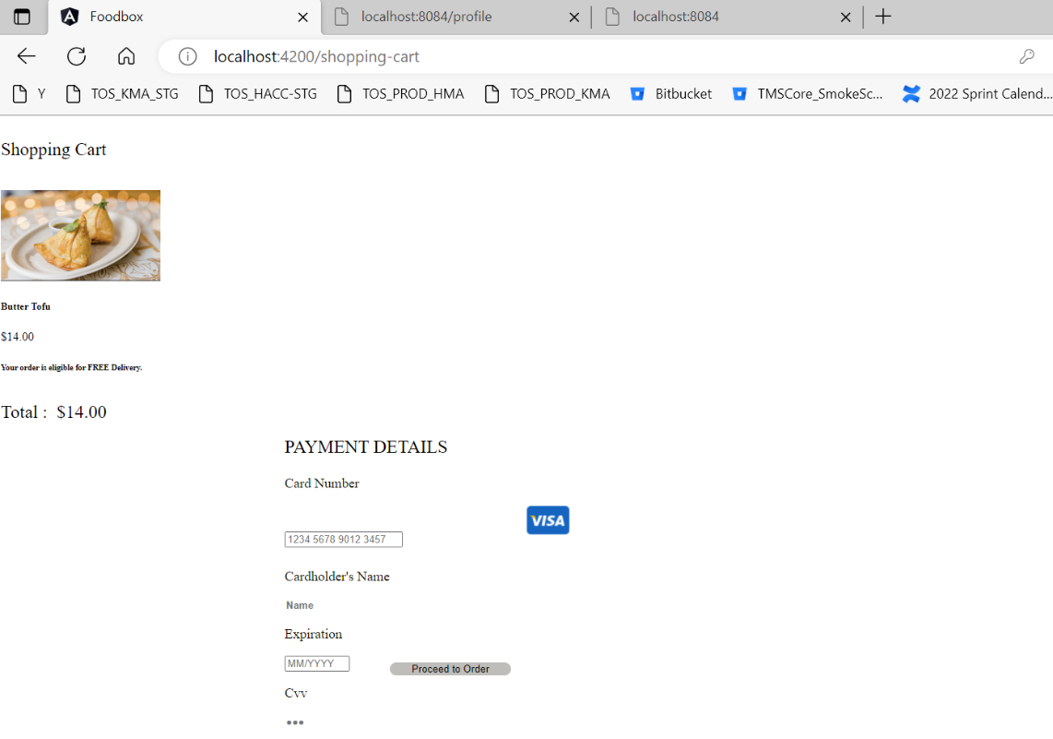

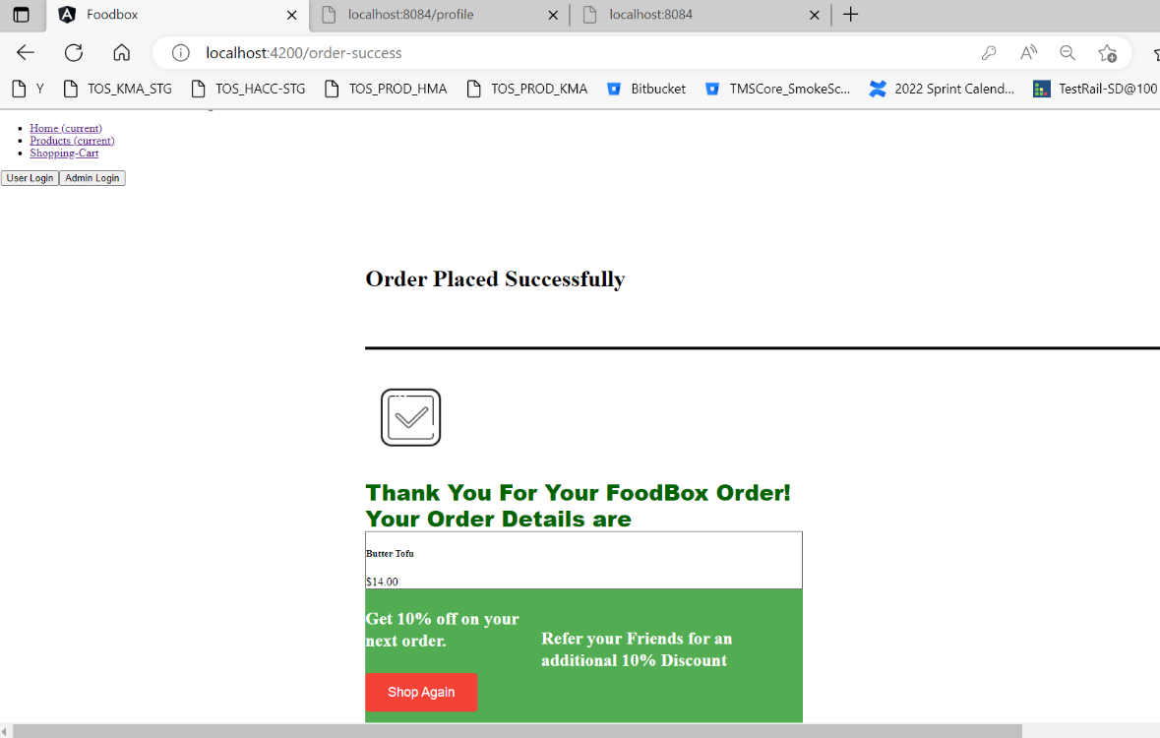

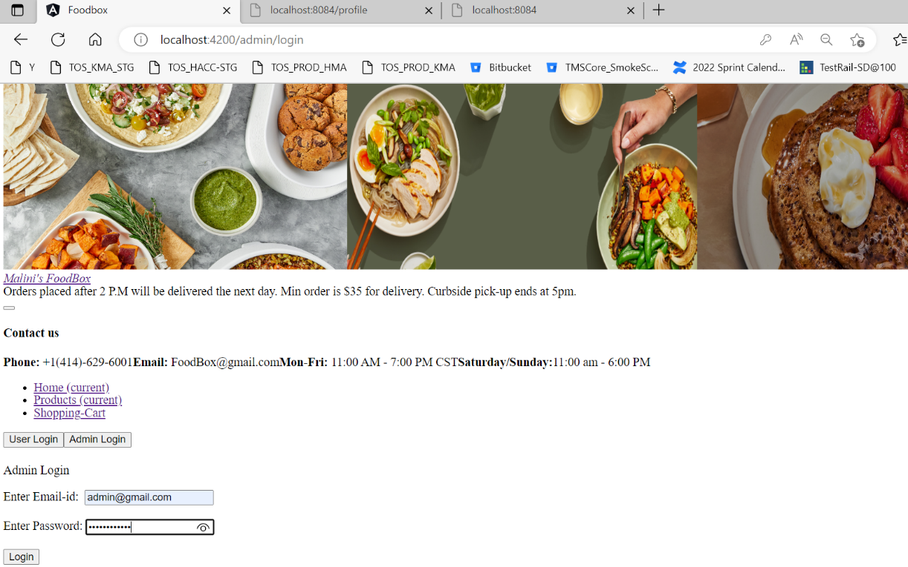

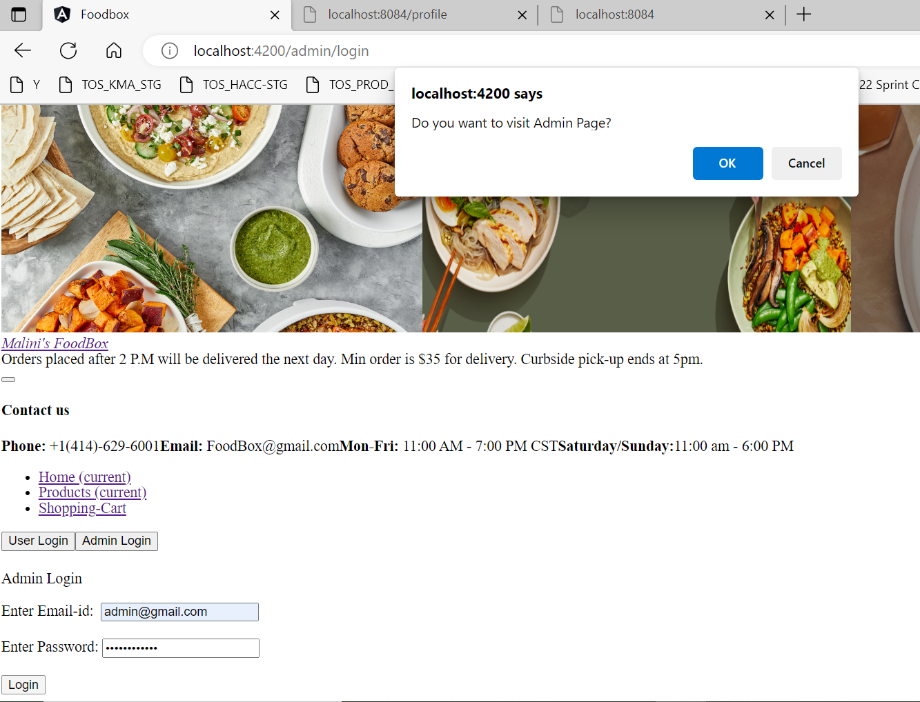

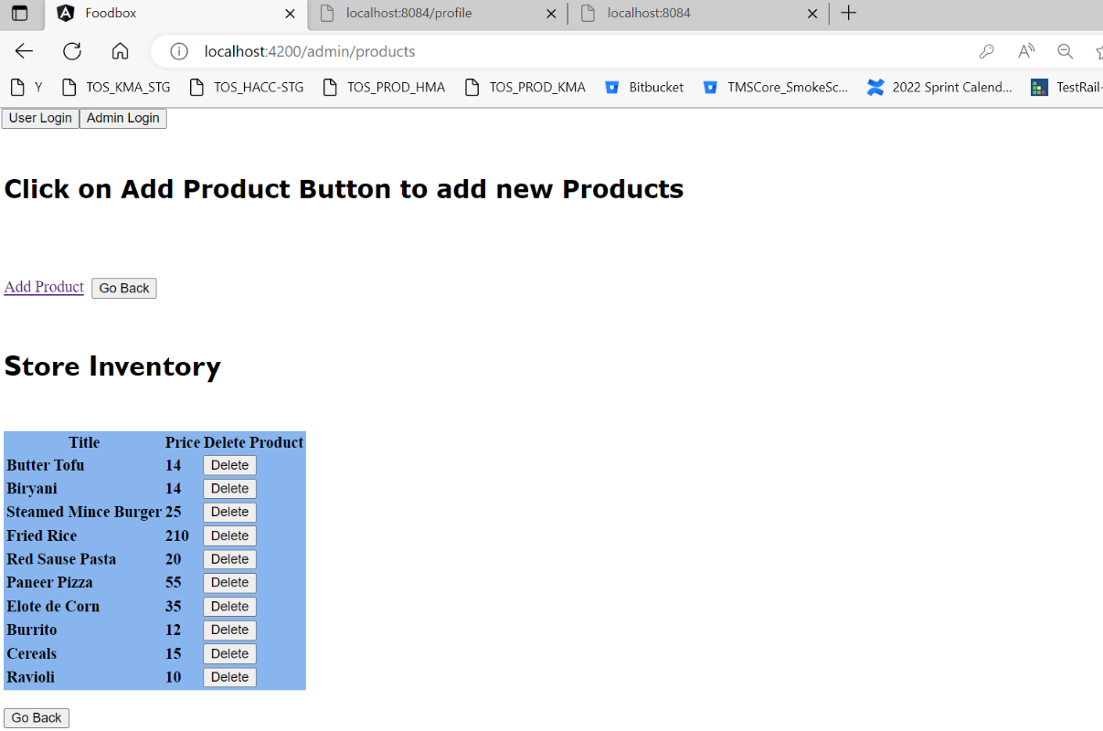

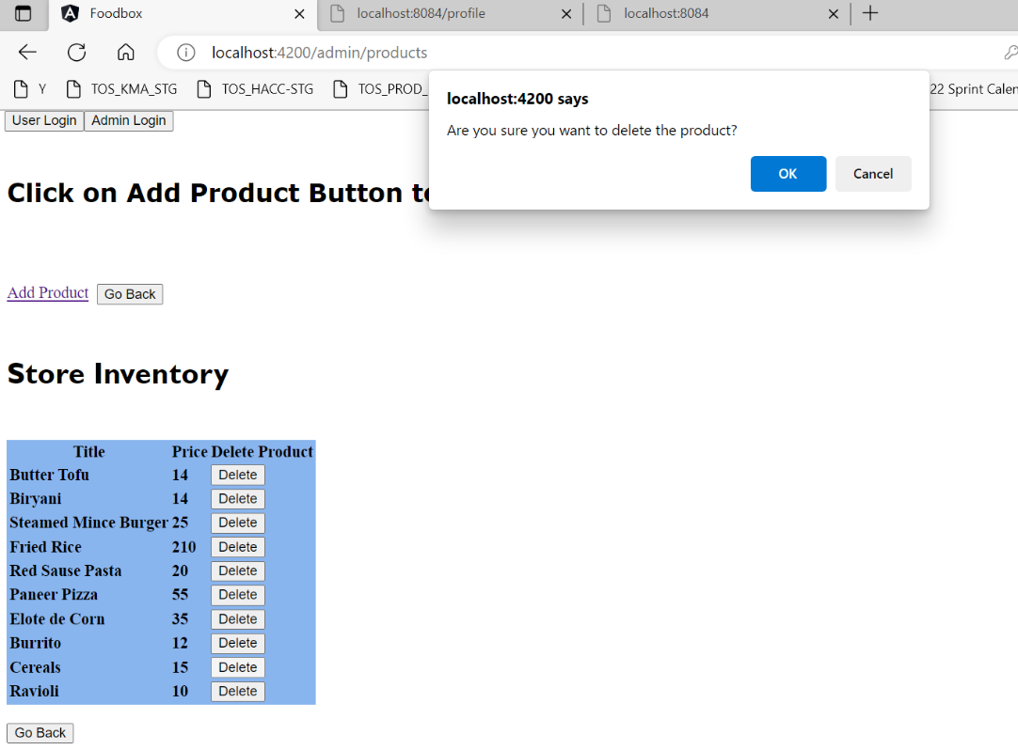

Cereals product got deleted:

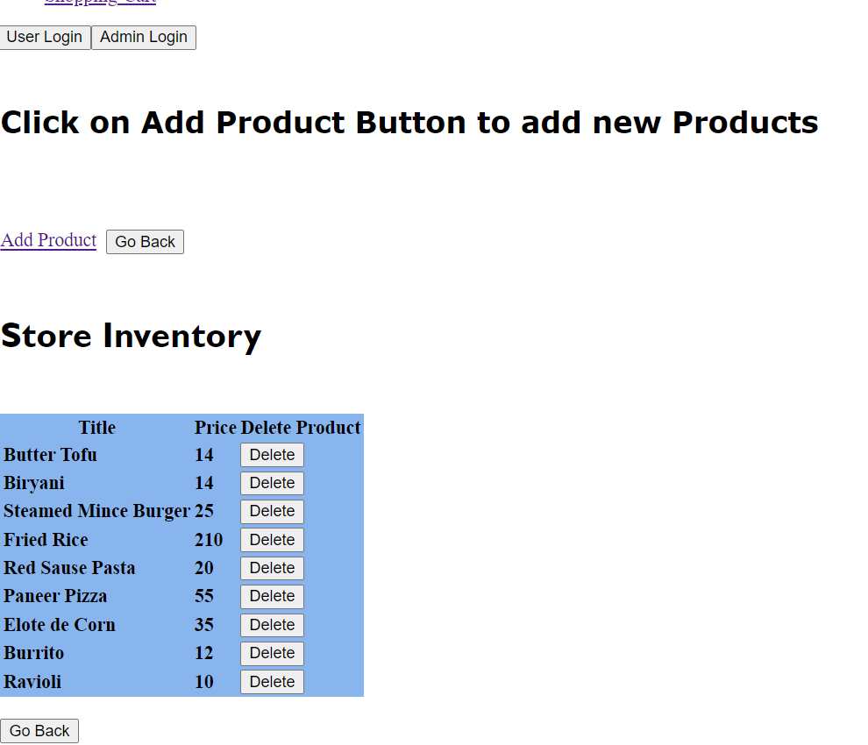

Add a new product: cereals

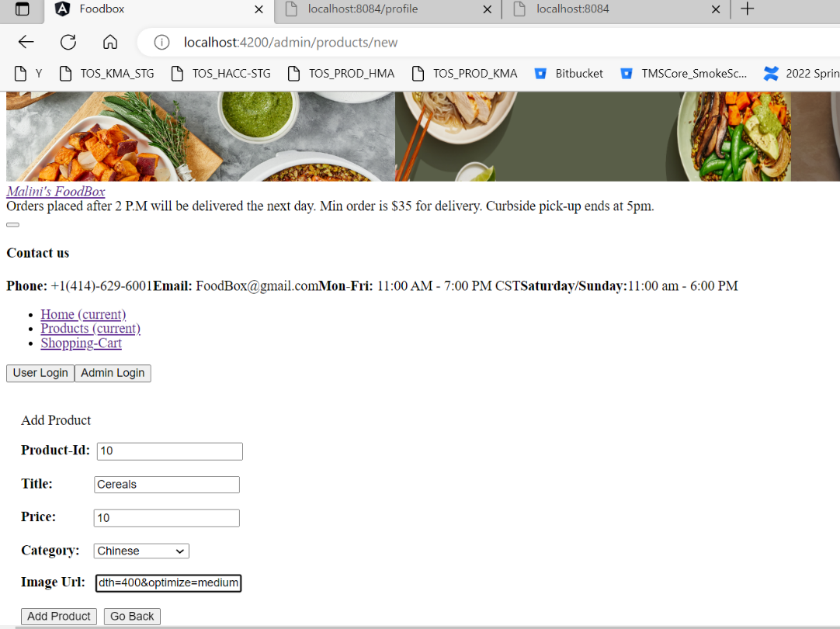

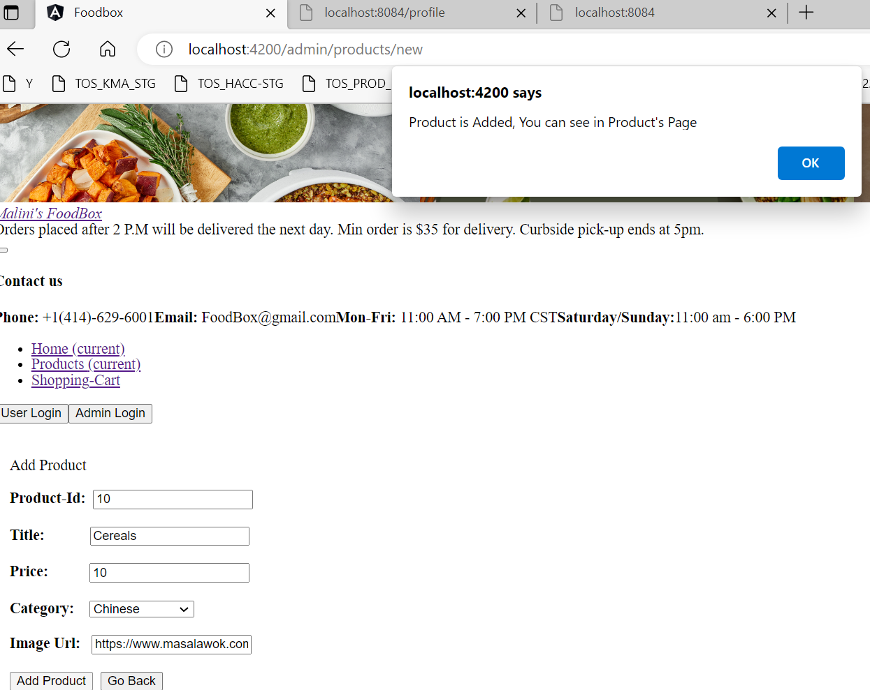

New product Cereals is added :

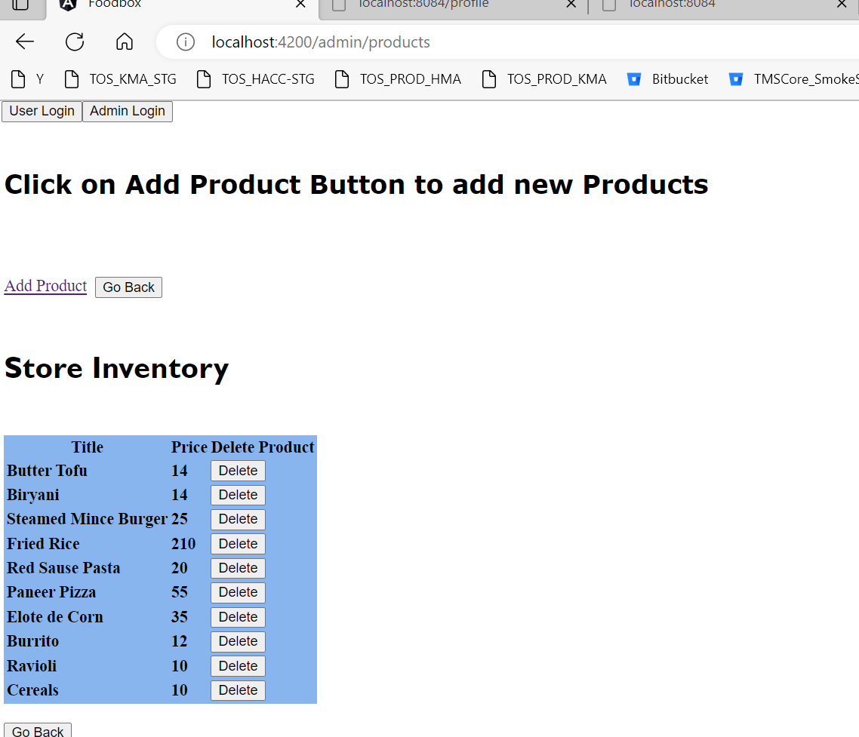

Back End Screens:

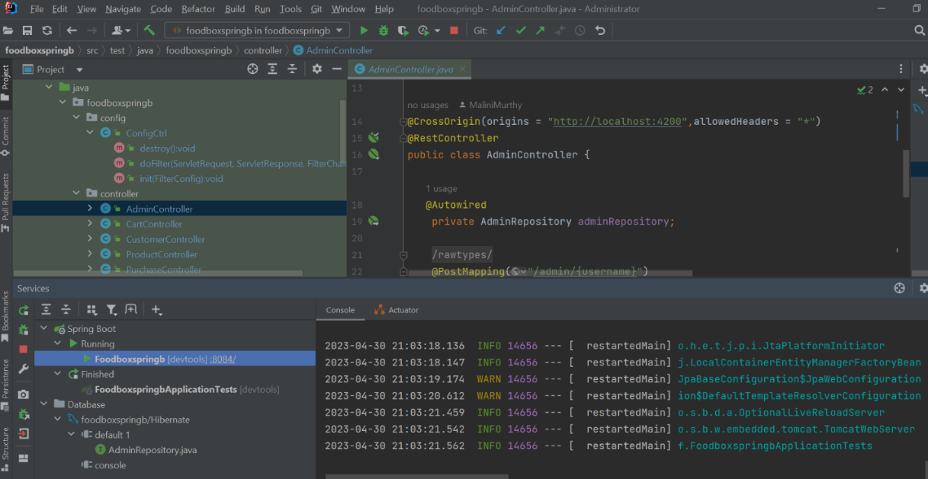

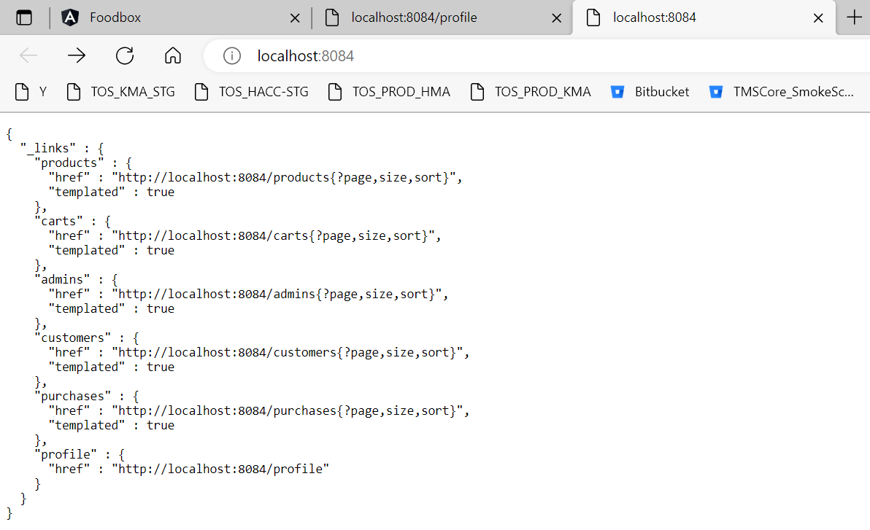

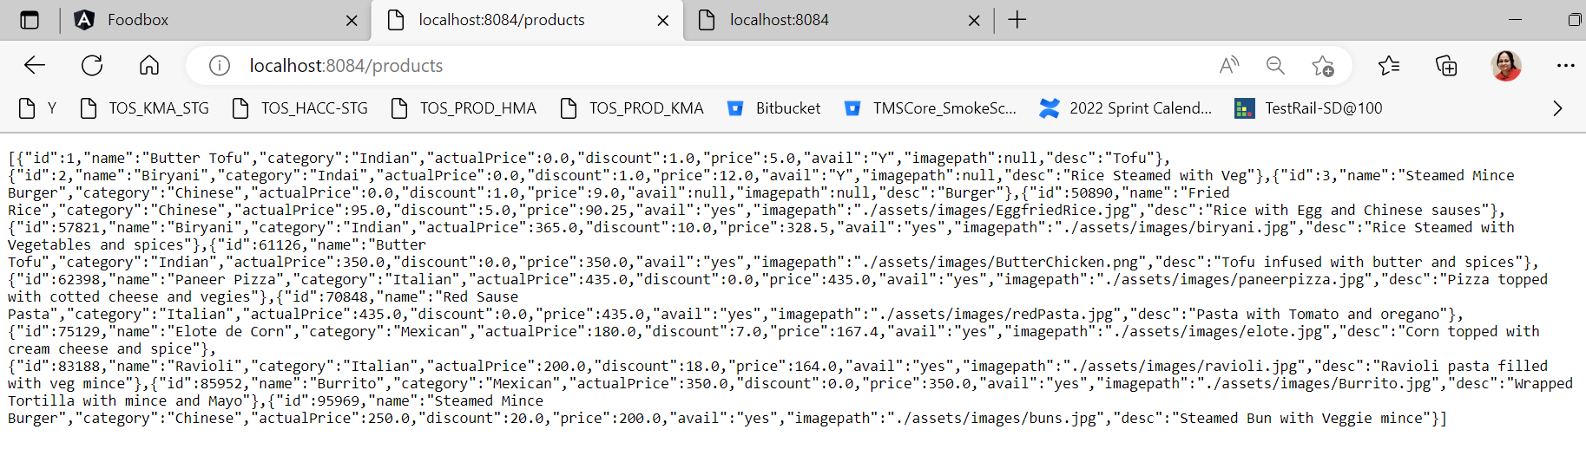

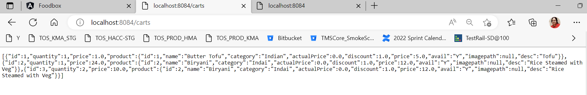

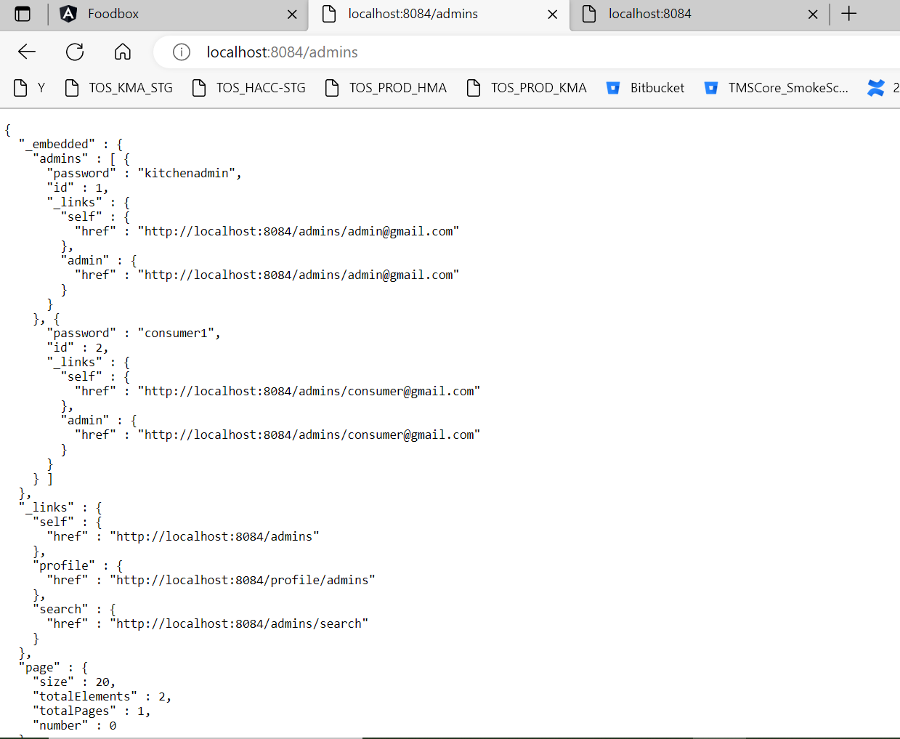

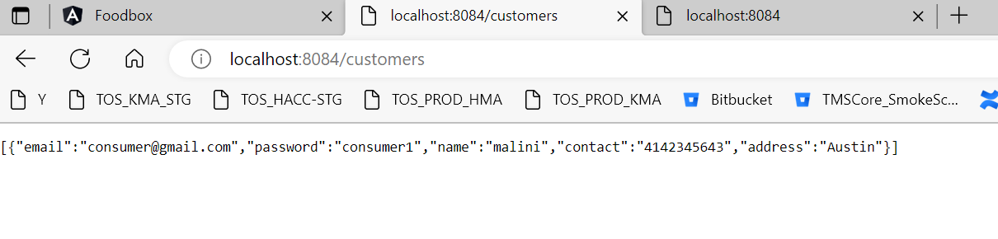

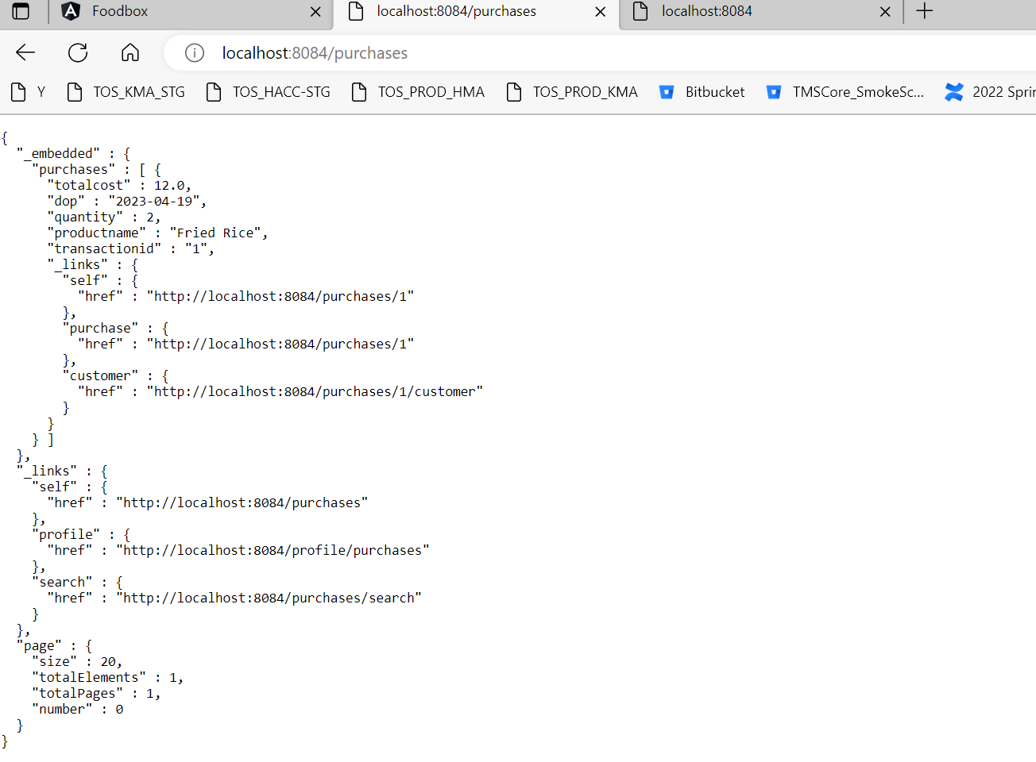

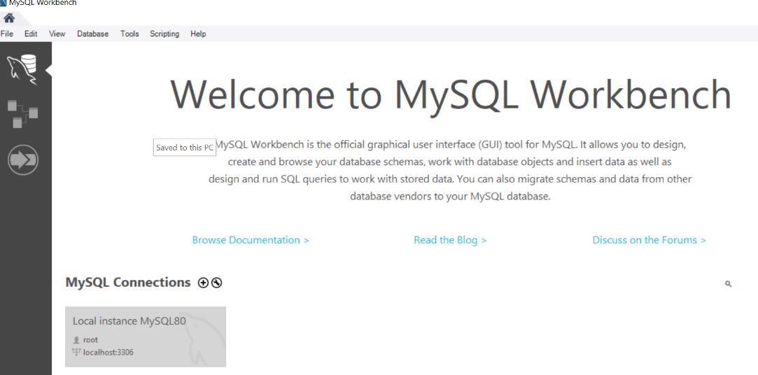

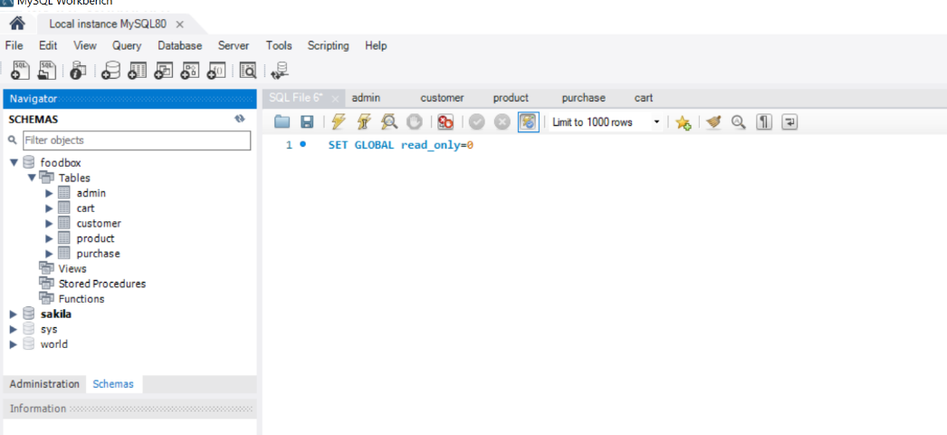

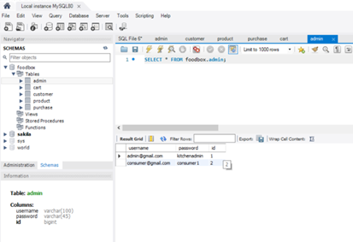

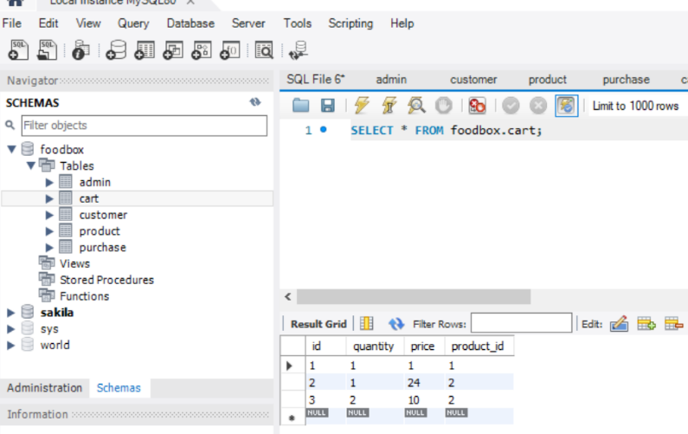

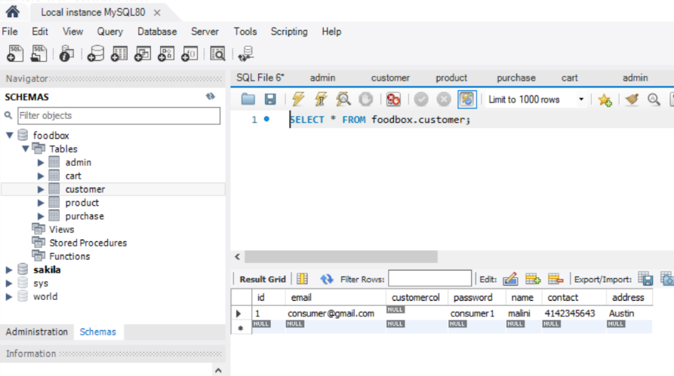

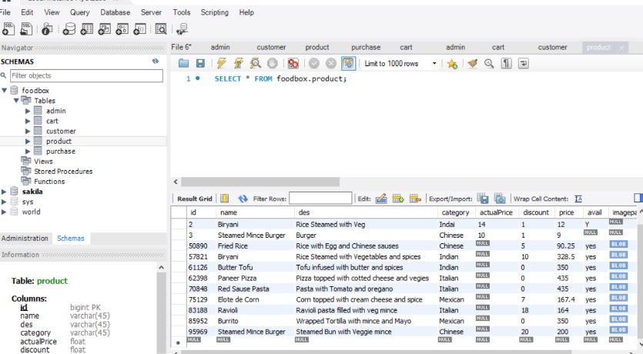

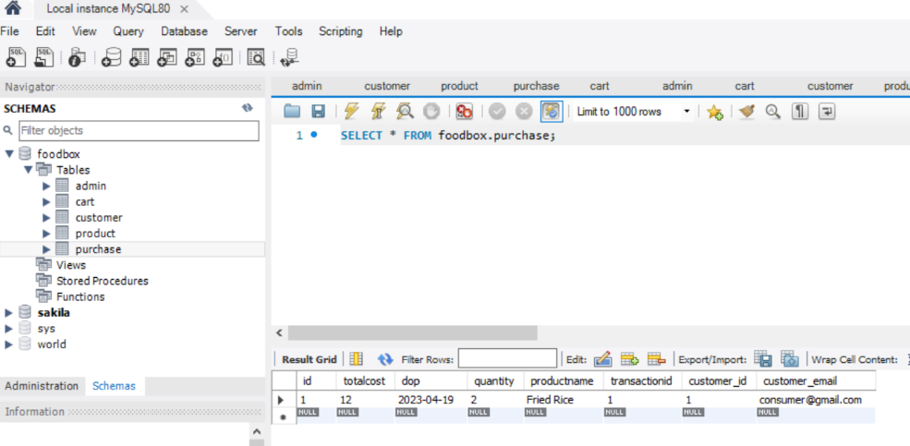

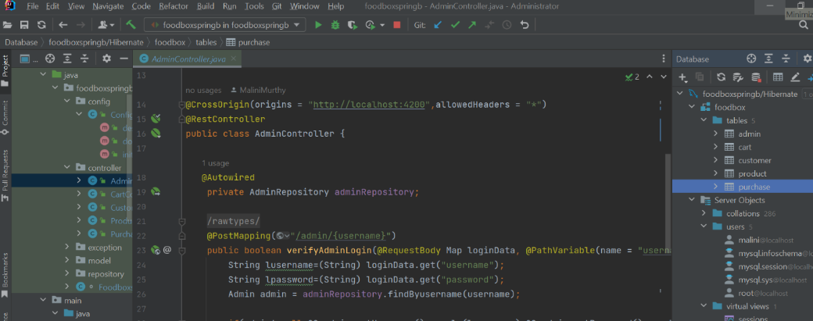

Dockerization:

